Educational Institutions Management and Monitoring System

(Use Case Modeling)

Course Name: Software Engineering and Information System Design

**Course No**: CSE 308

Group No**:** 06

Group Members:

1. A.M. Zoraf ---------------------------------- 1005106
2. Mohammad AminulHoque Ripon ----- 1005107
3. Bulbul Sharif Pias ------------------------- 1005108
4. Ashif Salman Rupsha -------------------- 1005109
5. Md. KamrulHasanShourov -------------- 1005097

Table of Contents:

1. Actors Glossary ………………………………………… 3
2. Use Case Glossary …………………………………….. 4
3. Use Case Diagram …………………………………….. 7
4. Use Case Narrative

4.1 Monitoring Teacher's Performance………………. 8

4.2 Monitoring Institution's Performance…………….. 10

4.3 Monitoring Student's Performance………………. 13

4.4 Book Distribution…………………………………… 15

4.5 PSC Online Registration………………………….. 17

1. Actors Glossary

|  |  |  |
| --- | --- | --- |
| Terms | Synonym | Description |
| Directorate of Primary and Mass Education | DPME | Initiates the process for calculating the total number of students. |
| Head of the Primary School and Kindergartens | P.S/K.G | Capable of creating teachers-students' profile, updating students' profile and receiving the list of the teachers' who need trainings. |
| District Primary Education Office | DPEO | Responsible for initiating training sessions, analyzing students', teachers' and institutions' profile and then can take proper steps. |
| Textbook Board | T.B | Receives the list of the students' and scheduling the book distribution process. |
| Invigilator |  | Monitors the book distribution process and laboratory and library facilities. |
| Head of the Secondary School | S.S | Capable of creating teachers-students' profile, updating students' profile and receiving the list of the teachers' who need trainings. |
| District Education Office | DEO | Responsible for initiating training sessions, analyzing students', teachers' and institutions' profile and then can take proper steps. |
| Directorate of Secondary and Higher Education | DSHE | Initiates the process for calculating the total number of students. |

1. Use Case Glossary

|  |  |  |
| --- | --- | --- |
| Use Case Name | Use Case Description | Participating Actors and Roles |
| Training Session | This use case provides facilities to train the disqualified teachers. | * District Primary Education Office ( DPEO )   [primary system actor]   * District Education Office (DEO)   [primary system actor] |
| Analyzing Teacher’s Profile | This use case analyzes teacher’s profileto know his educational qualification, number of trainings he has already receivedand the results of the students of that particular course that is being taught by him. | * Head of the Primary School or Kindergartens   [primary business actor]   * Head of the Secondary School   [primary business actor]   * District Primary Education Office ( DPEO )   [primary system actor]   * District Education Office (DEO)   [primary system actor] |
| Create New Teacher’s Profile | This use case creates new teacher’s profile with proper information. | * Head of the Primary School or Kindergartens   [primary system actor]   * Head of the Secondary School   [primary system actor] |
| Create New Student’s Profile | This use case creates new Student’s profile with proper information. | * Head of the Primary School or Kindergartens   [primary system actor]   * Head of the Secondary School   [primary system actor] |
| Institution’s Performance Monitoring and Taking Proper Steps | This use case analyzes Institution’s profileto know its teachers - students’ ratio, enough space to accommodate all the students, enough number of specialized teachers and qualification of teachers. After analyzing, proper steps are taken to improve Institution’s performance. | * District Primary Education Office ( DPEO )   [primary system actor]   * District Education Office (DEO)   [primary system actor] |
| Updating Student’s Profile | This use case updates each and every student’s profile under an institution with term examination results and attendance report. | * Head of the Primary School or Kindergartens   [primary system actor]   * Head of the Secondary School   [primary system actor] |
| Student’s Performance Monitoring and Taking Proper Steps | This use case analyzes student’s profileto know the performance of a student. The analysis of the result of the term examination and the percentage of the presence will help the authority to understand the weakness of a student and it will be easy for the authority to take proper action. Consequently, the performance of a student will be upgraded. | * District Primary Education Office ( DPEO )   [primary system actor]   * District Education Office (DEO)   [primary system actor] |
| Calculating Total Number of Students | This use case calculates the total number of students studying in primary/kindergartens and secondary schools. After knowing the total number of students, it is easy for Textbook board to print the necessary amount of books. | * Directorate of Primary and Mass Education   [primary system actor]   * Directorate of Secondary and Higher Education   [primary system actor]   * Textbook Board   [primary business actor] |
| Scheduling Book Distribution Process | This use case schedules and sends the information to all the institutions via message when and where they need to present to collect the books. | * Textbook Board   [primary system actor]   * Head of the Primary School or Kindergartens   [primary business actor]   * Head of the Secondary School   [primary business actor] |
| Monitoring Book Distribution Process | This use case monitors if the books correctly distributed among the institutions as their need and among the students. | * Invigilator [primary system actor] |
| Starting Online Registration | This use case starts when DPME send a message to the institutions in a digitalized way. The institution will take the responsibility for making online registration for each student of that institution going to take part in the examination. Since this process is not done manually rather than online, it will be easy to make correction if necessary. | * Directorate of Primary and Mass Education   [primary system – business actor]   * Head of the Primary School or Kindergartens   [primary system – business  actor] |
| Checking Registration Info | This use case starts when DPME sends a copy of every student’s registration info to the primary schools/kindergartens. After observing the data of every student, institutions then send the necessary information whether all the data is correct or some modification is necessary. If latter case is going to happen, then DPME will modify the wrong data. | * Directorate of Primary and Mass Education   [primary system – business actor]   * Head of the Primary School or Kindergartens   [primary system – business actor] |

1. Use Case Diagram

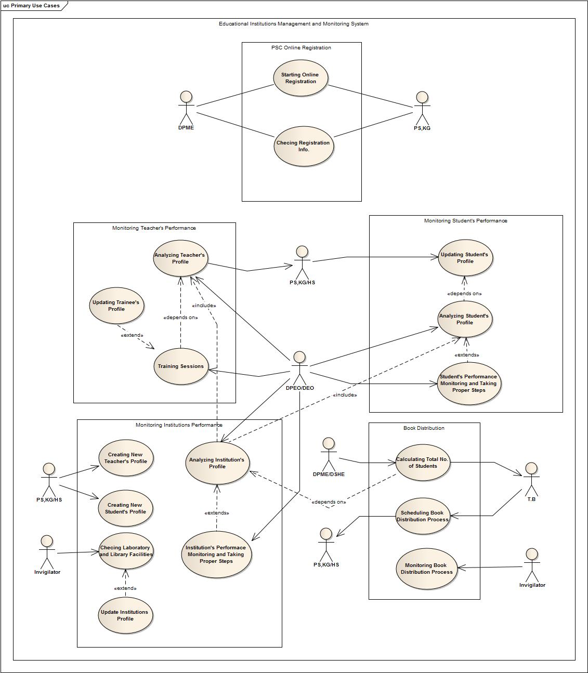

1. Use Case Narrative

# Monitoring Teacher’s Performance

## Use Case(s)

|  |  |  |  |  |
| --- | --- | --- | --- | --- |
| **Use Case ID:** | 4.1.1 | | | |
| **Use Case Name:** | Training Session | | | |
| **Date Created:** | 31 JAN, 2014 | | **Last Revision Date:** | 01 FEB, 2014 |
| **Actors:** | | * District Primary Education Office ( DPEO )   [primary system actor]   * District Education Office (DEO)   [primary system actor] | | |
| **Description:** | | This use case provides facilities to train the disqualified teachers. | | |
| **Trigger:** | | Normally DPEO or DEO initiates this use case. | | |
| **Preconditions:** | | It mainly depends on the ‘Analyzing Teacher’s Profile’ use case for identifying those who need trainings. | | |
| **Postconditions:** | | Update the database fields correspond to the trainee so that further training sessions can identify the correct candidate for trainings. | | |
| **Typical Course of Events:** | | |  |  | | --- | --- | | Actor Action | System Response | | Step 1: Clicks "Select Trainee List" button.  Step 2: Clicks the button "Add Teacher".  Step 4: Fields are filled with proper data.  Step 6: Clicks the button "Complete". | Step 3: New page for inserting teacher's name, institution and subject is open.  Step 5: All data are saved and corresponding teacher's profile is updated.  Step 7: Saves the full list. | | | |
| **Alternative Courses:** | | Alt-step 4: Fields are not filled perfectly.  Alt-step 5: Shows error messages and opens new page to input. | | |
| **Includes:** | | None. | | |
| **Frequency of Use:** | | Once a year. | | |
| **Assumptions:** | | This use case will assume that all data entry in Teacher’s profile is accurate. | | |

|  |  |  |  |  |
| --- | --- | --- | --- | --- |
| **Use Case ID:** | 4.1.2 | | | |
| **Use Case Name:** | Analyzing Teacher’s Profile | | | |
| **Date Created:** | 31 JAN, 2014 | | **Last Revision Date:** | 01 FEB, 2014 |
| **Actors:** | | * Head of the Primary School or Kindergartens   [primary business actor]   * Head of the Secondary School   [primary business actor]   * District Primary Education Office ( DPEO )   [primary system actor]   * District Education Office (DEO)   [primary system actor] | | |
| **Description:** | | This use case analyzes teacher’s profileto know his educational qualification, number of trainings he has already receivedand the results of the students of that particular course that is being taught by him. | | |
| **Trigger:** | | “Training Session” and “Analyzing Institution’s Profile” use case trigger this use case. | | |
| **Preconditions:** | | “Create New Teacher’s Profile” use case has to be executed at the beginning of the System but after that it doesn’t depend on any use cases. | | |
| **Conclusion:** | | Concludes when all the profile given a rating. | | |
| **Postconditions:** | | A list of all the teachers is made and shown. | | |
| **Typical Course of Events:** | | |  |  | | --- | --- | | Actor Action | System Response | | Step 1: Clicks the button "Analyze Teacher's Profile".  Step 3: Fills the form and click "Submit" button. | Step 2: A new page is open with some fields which are about the category of teachers.  Step 4: Starts analyzing with the data of profile and the result of that teachers.  Step 5: Gives a rating to all the teachers who are under the given category.  Step 6: Shows the list with rating. | | | |
| **Alternative Courses:** | | Alt-step 3: Fields are not filled perfectly.  Alt-step 4: Shows error messages and opens new page to input. | | |
| **Includes:** | | None. | | |
| **Assumptions:** | | This use case will assume that all data entry in Teacher’s profile is accurate. | | |

# Monitoring Institution’s Performance:

Use Case(s):

|  |  |  |  |  |
| --- | --- | --- | --- | --- |
| **Use Case ID:** | 4.2.1 | | | |
| **Use Case Name:** | Create New Teacher’s Profile | | | |
| **Date Created:** | 31 JAN, 2014 | | **Last Revision Date:** | 01 FEB, 2014 |
| **Actors:** | | * Head of the Primary School or Kindergartens   [primary system actor]   * Head of the Secondary School   [primary system actor] | | |
| **Description:** | | This use case creates new teacher’s profile with proper information. | | |
| **Trigger:** | | Head of the Primary School or Kindergartens or Head of the Secondary School triggers this use case. | | |
| **Preconditions:** | | It loosely depends on “Institution Performance Monitoring and Taking Proper Steps” use case. | | |
| **Conclusions:** | | Create a profile for a new teacher under the institution and save all the information of the teacher in the database. | | |
| **Post Conditions:** | | None | | |
| **Typical Course of Events:** | | |  |  | | --- | --- | | Actor Action | System Response | | Step 1: Login to create new teacher's profile.  Step 3: Selects "Add Teacher" option from the option list and clicks "OK" button.  Step 5: Proper information will be given in the respective fields. | Step 2: User ID and Password is verified and page for choosing option is open.  Step 4: New page for insertion teacher's information is open. | | | |
| **Alternative Courses:** | | Alt-step 1: May give wrong user ID and password.  Alt-step 2: Provide new login page. | | |
| **Includes:** | | None. | | |
| **Assumptions:** | | This use case will assume that all data entry in Teacher’s profile is accurate. | | |

|  |  |  |  |  |
| --- | --- | --- | --- | --- |
| **Use Case ID:** | 4.2.2 | | | |
| **Use Case Name:** | Create New Student’s Profile | | | |
| **Date Created:** | 31 JAN, 2014 | | **Last Revision Date:** | 01 FEB, 2014 |
| **Actors:** | | * Head of the Primary School or Kindergartens   [primary system actor]   * Head of the Secondary School   [primary system actor] | | |
| **Description:** | | This use case creates new Student’s profile with proper information. | | |
| **Trigger:** | | Head of the Primary School or Kindergartens or Head of the Secondary School triggers this use case. | | |
| **Preconditions:** | | None | | |
| **Conclusions:** | | Create a profile for a new student under the institution and save all the information of the student in the database. | | |
| **Post Conditions:** | | None | | |
| **Typical Course of Events:** | | |  |  | | --- | --- | | Actor Action | System Response | | Step 1: Login to create new student's profile.  Step 3: Selects "Add Student" option from the option list and clicks "OK" button.  Step 5: Proper information will be given in the respective fields. | Step 2: User ID and Password is verified and page for choosing option is open.  Step 4: New page for insertion student's information is open. | | | |
| **Alternative Courses:** | | Alt-step 1: May give wrong user ID and password.  Alt-step 2: Provide new login page. | | |
| **Includes:** | | None. | | |
| **Assumptions:** | | This use case will assume that all data entry in Student’s profile is accurate. | | |

|  |  |  |  |  |
| --- | --- | --- | --- | --- |
| **Use Case ID:** | 4.2.3 | | | |
| **Use Case Name:** | Institution’s Performance Monitoring and Taking Proper Steps | | | |
| **Date Created:** | 31 JAN, 2014 | | **Last Revision Date:** | 01 FEB, 2014 |
| **Actors:** | | * District Primary Education Office ( DPEO )   [primary system actor]   * District Education Office (DEO)   [primary system actor] | | |
| **Description:** | | This use case analyzes Institution’s profileto know itsteachers - students’ ratio, enough space to accommodate all the students, enough number of specialized teachers and qualification of teachers. After analyzing, proper steps are taken to improve Institution’s performance. | | |
| **Trigger:** | | DEPO/DEOtriggers this use case. | | |
| **Conclusion:** | | Given a rating to all the institutions after analyzing the necessary fields and further steps are taken according to the rating. | | |
| **Typical Course of Events:** | | |  |  | | --- | --- | | Actor Action | System Response | | Step 1: Clicks the button "Analyze Institution's Profile".  Step 3: Fills the form and click "Submit" button. | Step 2: A new page is open with some fields which are about the category of institutions.  Step 4: Starts analyzing with the data of institutions’.  Step 5: Gives a rating to all the institutionsthat are under the given category.  Step 6: Shows the list with rating.  Step 7: Proper steps are taken according to the rating. | | | |
| **Alternative Courses:** | | Alt-step 3: Fields are not filled perfectly.  Alt-step 4: Shows error messages and opens new page to input. | | |
| **Includes:** | | “Analyzing Teacher’s Profile” and “Analyzing Student’s Profile” | | |
| **Assumptions:** | | This use case will assume that all data entry in respective profilesis accurate. | | |

# Monitoring Student’s Performance:

Use Case(s)

|  |  |  |  |  |
| --- | --- | --- | --- | --- |
| **Use Case ID:** | 4.3.1 | | | |
| **Use Case Name:** | Updating Student’s Profile | | | |
| **Date Created:** | 31 JAN, 2014 | | **Last Revision Date:** | 01 FEB, 2014 |
| **Actors:** | | * Head of the Primary School or Kindergartens   [primary system actor]   * Head of the Secondary School   [primary system actor] | | |
| **Description:** | | This use case updates each and every student’s profile under an institution with term examination results and attendance report. | | |
| **Trigger:** | | Head of the Primary School or Kindergartens or Head of the Secondary School triggers this use case. | | |
| **Preconditions:** | | None | | |
| **Conclusions:** | | Concludes when the profiles of all the students are updated. | | |
| **Post Conditions:** | | Performs some related calculations. | | |
| **Typical Course of Events:** | | |  |  | | --- | --- | | Actor Action | System Response | | Step 1: Gives the data about semester examination result and attendance. | Step 2: Updates profile of each student with the given data. | | | |
| **Includes:** | | None. | | |
| **Assumptions:** | | This use case will assume that all data entry in Student’s profile is accurate. | | |

|  |  |  |  |  |
| --- | --- | --- | --- | --- |
| **Use Case ID:** | 4.3.2 | | | |
| **Use Case Name:** | Student’s Performance Monitoring and Taking Proper Steps | | | |
| **Date Created:** | 31 JAN, 2014 | | **Last Revision Date:** | 01 FEB, 2014 |
| **Actors:** | | * District Primary Education Office ( DPEO )   [primary system actor]   * District Education Office (DEO)   [primary system actor] | | |
| **Description:** | | This use case analyzes student’s profileto know the performance of a student. The analysis of the result of the term examination and the percentage of the presence will help the authority to understand the weakness of a student and it will be easy for the authority to take proper action. Consequently, the performance of a student will be upgraded. | | |
| **Trigger:** | | DPEO/DEO triggers this use case. | | |
| **Preconditions:** | | “Updating Student’s Profile” use case has to be executed. | | |
| **Conclusion:** | | Concludes when all the profile given a rating. | | |
| **Typical Course of Events:** | | |  |  | | --- | --- | | Actor Action | System Response | | Step 1: Clicks the button "Analyze Student's Profile".  Step 3: Fills the form and click "Submit" button. | Step 2: A new page is open with some fields which are about the category of teachers.  Step 4: Starts analyzing with the data of profile and the result of that students.  Step 5: Gives a rating to all the students who are under the given category.  Step 6: Shows the list with rating.  Step 7: Taking Further steps according to the rating. | | | |
| **Alternative Courses:** | | Alt-step 3: Fields are not filled perfectly.  Alt-step 4: Shows error messages and opens new page to input. | | |
| **Includes:** | | None. | | |
| **Assumptions:** | | This use case will assume that all data entry in Student’s profile is accurate. | | |

# Book Distribution:

Use Case(s)

|  |  |  |  |  |
| --- | --- | --- | --- | --- |
| **Use Case ID:** | 4.4.1 | | | |
| **Use Case Name:** | Calculating Total Number of Students | | | |
| **Date Created:** | 31 JAN, 2014 | | **Last Revision Date:** | 01 FEB, 2014 |
| **Actors:** | | * Directorate of Primary and Mass Education   [primary system actor]   * Directorate of Secondary and Higher Education   [primary system actor]   * Textbook Board   [primary business actor] | | |
| **Description:** | | This use case calculates the total number of students studying in primary/kindergartens and secondary schools. After knowing the total number of students, it is easy for Textbook board to print the necessary amount of books. | | |
| **Trigger:** | | Directorate of Primary and Mass Education and Directorate of Secondary and Higher Education trigger this use case. | | |
| **Preconditions:** | | None | | |
| **Conclusions:** | | Concludes when the data is send to Textbook Board. | | |
| **Post Conditions:** | | None | | |
| **Typical Course of Events:** | | |  |  | | --- | --- | | Actor Action | System Response | | Step 1: DPME/DSHE gives the command to calculate the number of students.  Step 4: Textbook Board receives the data and prints required number of books. | Step 2: Calculates the total number of students of all the institutions.  Step 3: Sends the data to Textbook Board. | | | |
| **Includes:** | | None. | | |
| **Assumptions:** | | This use case will assume that all data entry in Institution’s profile is accurate. | | |

|  |  |  |  |  |
| --- | --- | --- | --- | --- |
| **Use Case ID:** | 4.4.2 | | | |
| **Use Case Name:** | Scheduling Book Distribution Process | | | |
| **Date Created:** | 31 JAN, 2014 | | **Last Revision Date:** | 01 FEB, 2014 |
| **Actors:** | | * Textbook Board   [primary system actor]   * Head of the Primary School or Kindergartens   [primary business actor]   * Head of the Secondary School   [primary business actor] | | |
| **Description:** | | This use case schedules and sends the information to all the institutions via message when and where they need to present to collect the books. | | |
| **Trigger:** | | Textbook Board triggers this use case. | | |
| **Preconditions:** | | None | | |
| **Conclusions:** | | Sending scheduling to all the institutions to collect their share. | | |
| **Post Conditions:** | | None. | | |
| **Typical Course of Events:** | | |  |  | | --- | --- | | Actor Action | System Response | | Step 1: Textbook Board prepares the schedule for distribution of books.  Step 2: Schedule is given to the system. | Step 3: Informs about the scheduled date to corresponding institutions. | | | |
| **Includes:** | | None. | | |
| **Assumptions:** | | This use case will assume that information about when and where books will be distributed, will receive timely and accurately. | | |

|  |  |  |  |  |
| --- | --- | --- | --- | --- |
| **Use Case ID:** | 4.4.3 | | | |
| **Use Case Name:** | Monitoring Book Distribution Process | | | |
| **Date Created:** | 31 JAN, 2014 | | **Last Revision Date:** | 01 FEB, 2014 |
| **Actors:** | | * Invigilator [primary system actor] | | |
| **Description:** | | This use case monitors if the books correctly distributed among the institutions as their need and among the students. | | |
| **Trigger:** | | Invigilator triggers this process. | | |
| **Preconditions:** | | “Scheduling Book Distribution Process” use case must be executed. | | |
| **Conclusions:** | | Concludes with taking proper steps against the institutions who black marketed the books. | | |
| **Post Conditions:** | | None. | | |
| **Typical Course of Events:** | | |  |  | | --- | --- | | Actor Action | System Response | | Step 1: Invigilates the distribution process in school level.  Step 2: Collects and uploads the data about how many students have received book in hand. | Step 3: Updates the profile of the school with the data. | | | |
| **Includes:** | | None. | | |
| **Assumptions:** | | This use case will assume that invigilator does his job honestly and professionally. | | |

# PSC Online Registration:

Use Cases(s)

|  |  |  |  |  |
| --- | --- | --- | --- | --- |
| **Use Case ID:** | 4.5.1 | | | |
| **Use Case Name:** | Starting Online Registration | | | |
| **Date Created:** | 31 JAN, 2014 | | **Last Revision Date:** | 01 FEB, 2014 |
| **Actors:** | | * Directorate of Primary and Mass Education   [primary system – business actor]   * Head of the Primary School or Kindergartens   [primary system – business actor] | | |
| **Description:** | | This use case starts when DPME send a message to the institutions in a digitalized way. The institution will take the responsibility for making online registration for each student of that institution going to take part in the examination. Since this process is not done manually rather than online, it will be easy to make correction if necessary. | | |
| **Trigger:** | | DPME triggers this process. | | |
| **Conclusions:** | | Concludes with receiving students’ information from the institutions. | | |
| **Post Conditions:** | | “Checking Registration Info.” Use case may initiates if necessary. | | |
| **Typical Course of Events:** | | |  |  | | --- | --- | | Actor Action | System Response | | Step 1: DPME starts the registration process.  Step 3: P.S/K.G gives the necessary data of all the students of class Five. | Step 2: Shows the registration option to K.G/ P.S.  Step 4: Saves all the data. | | | |
| **Includes:** | | None. | | |
| **Assumptions:** | | This use case will assume that “Computer and Internet” facilities are available across the country. | | |

|  |  |  |  |  |
| --- | --- | --- | --- | --- |
| **Use Case ID:** | 4.5.2 | | | |
| **Use Case Name:** | Checking Registration Info | | | |
| **Date Created:** | 31 JAN, 2014 | | **Last Revision Date:** | 01 FEB, 2014 |
| **Actors:** | | * Directorate of Primary and Mass Education   [primary system – business actor]   * Head of the Primary School or Kindergartens   [primary system – business actor] | | |
| **Description:** | | This use case starts when DPME sends a copy of every student’s registration info to the primary schools/kindergartens. After observing the data of every student, institutions then send the necessary information whether all the data is correct or some modification is necessary. If latter case is going to happen, then DPME will modify the wrong data. | | |
| **Trigger:** | | DPME triggers this process. | | |
| **Conclusions:** | | Concludes with updating students’ information if necessary. | | |
| **Typical Course of Events:** | | |  |  | | --- | --- | | Actor Action | System Response | | Step 1: DPME starts error checking event.  Step 3: P.S/K.G checks the list of all students.  Step 4: If error is found, clicks the "Edit" button.  Step 6: Completes the necessary editing and clicks the button "Done". | Step 2: Shows error checking option to P.S/K.G.  Step 5: An editable form is opened with all the previous data.  Step 7: Saves the data. | | | |
| **Includes:** | | None. | | |